Penetration Testing

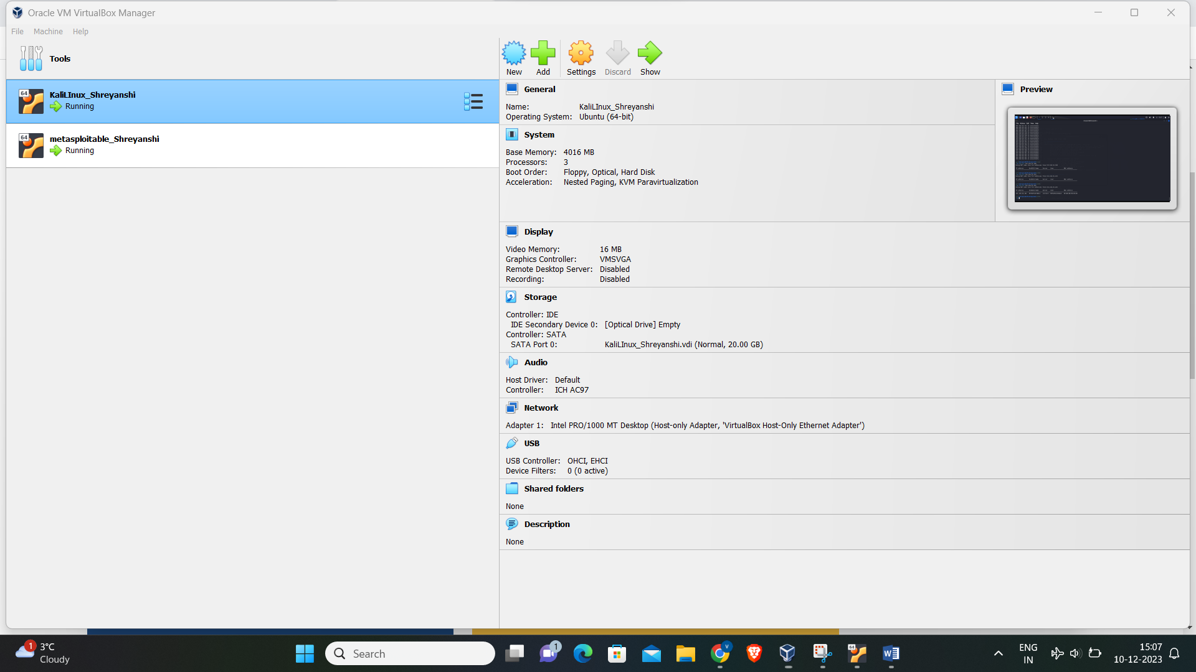

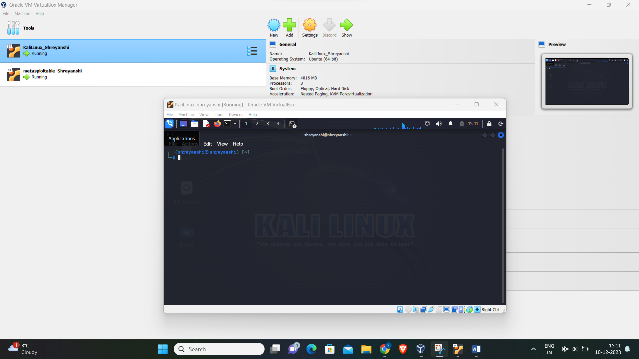

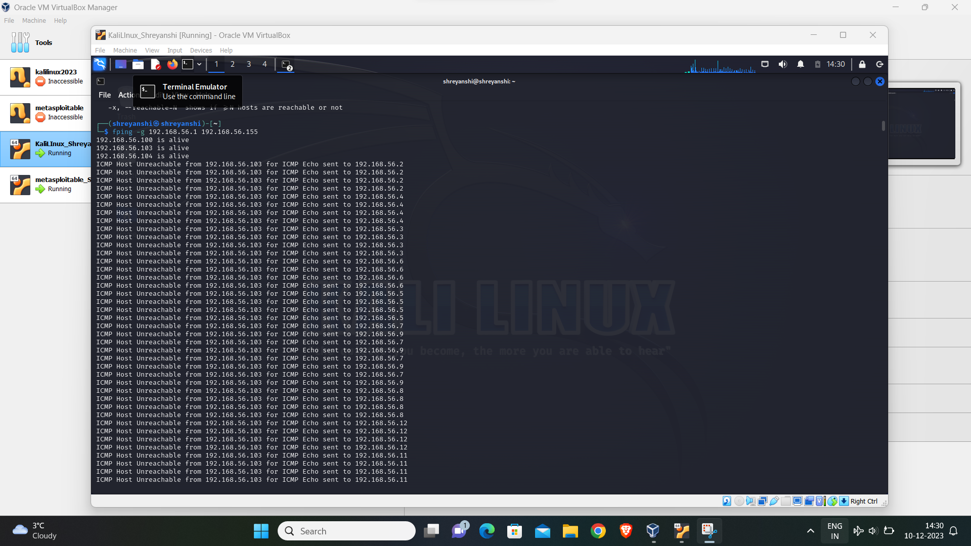

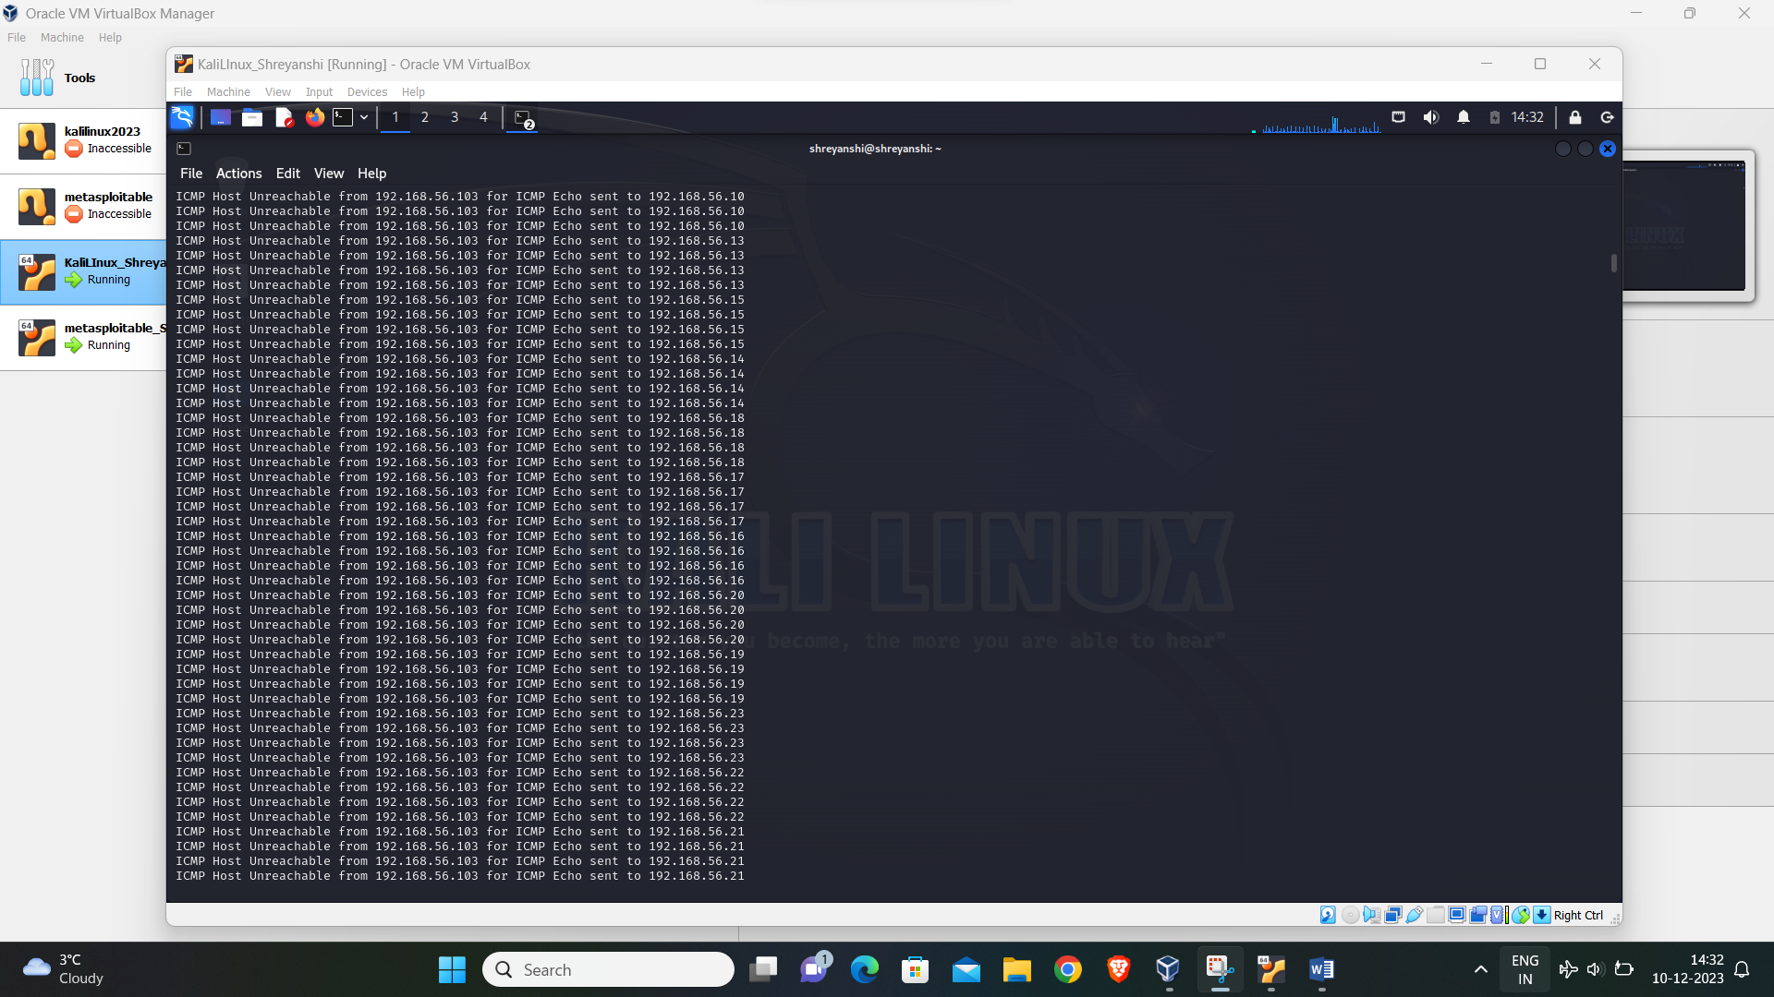

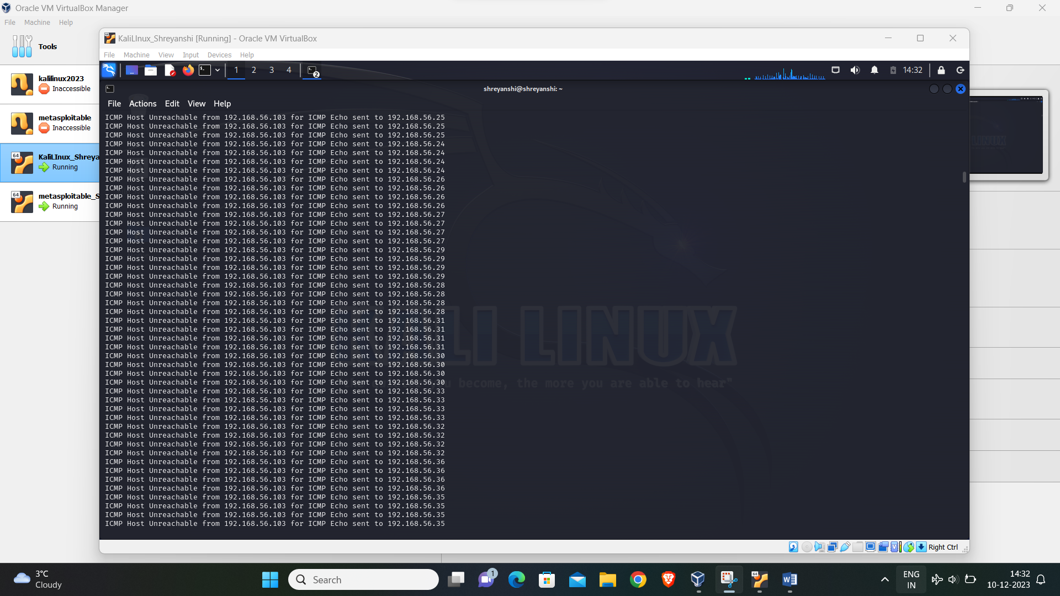

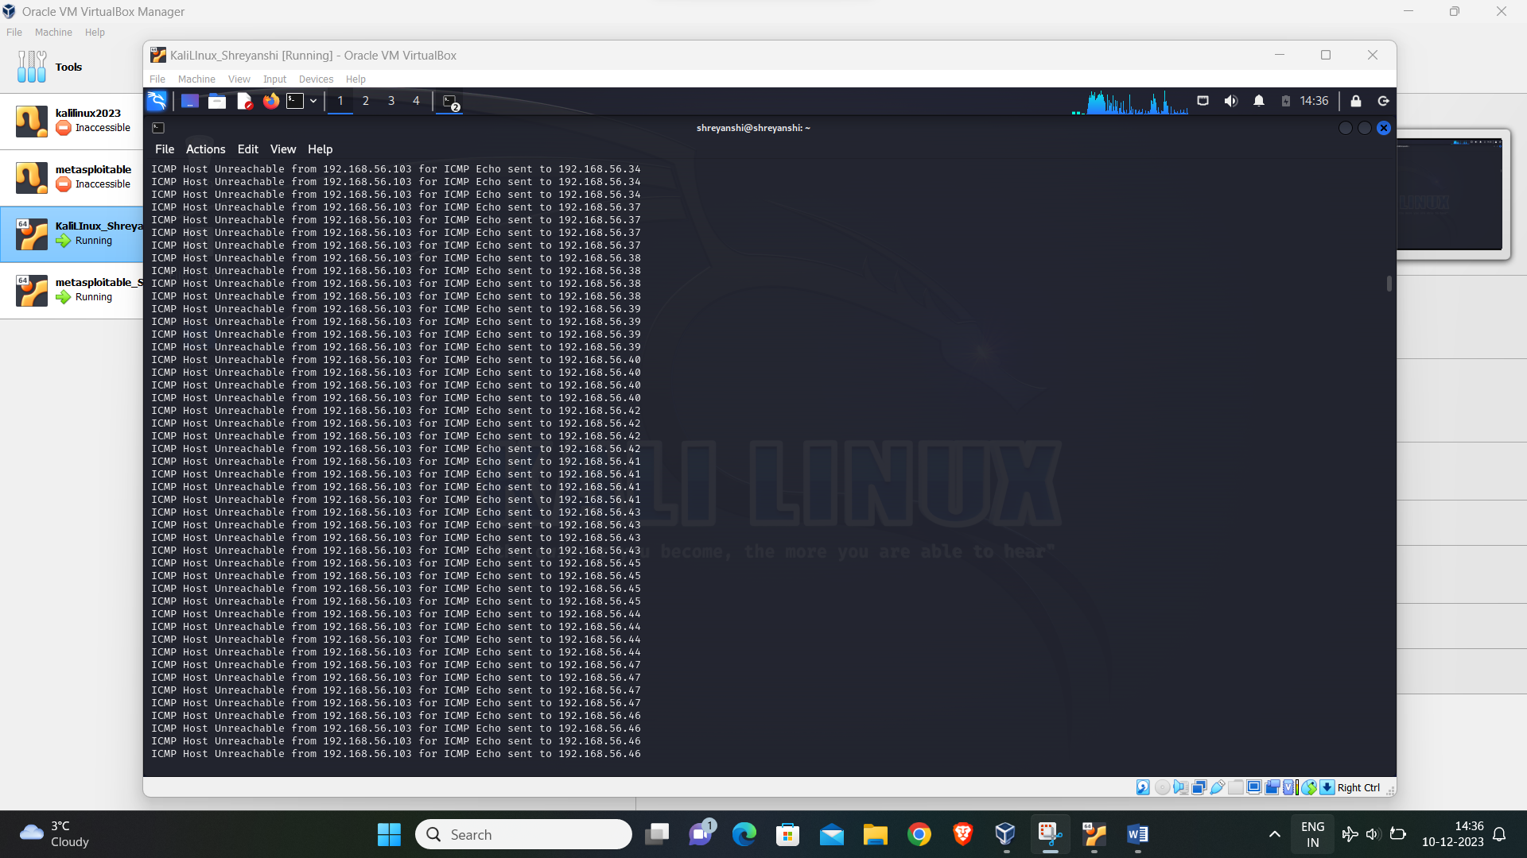

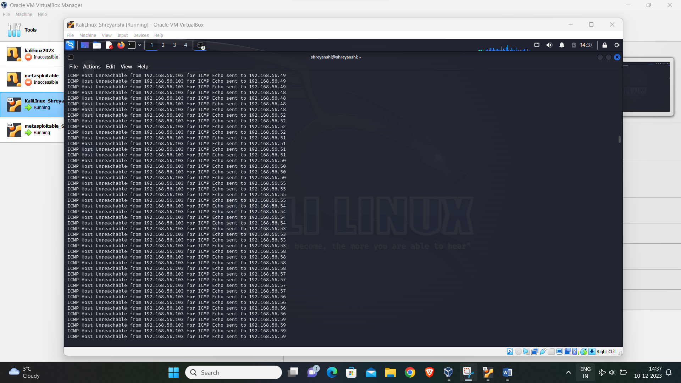

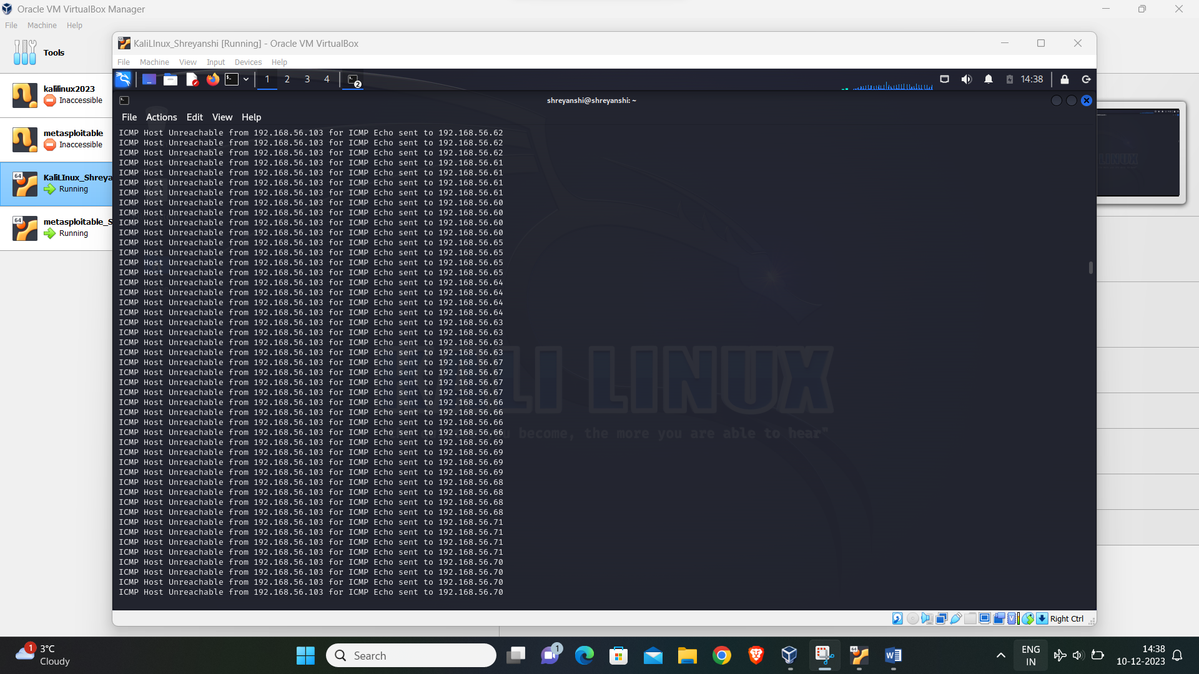

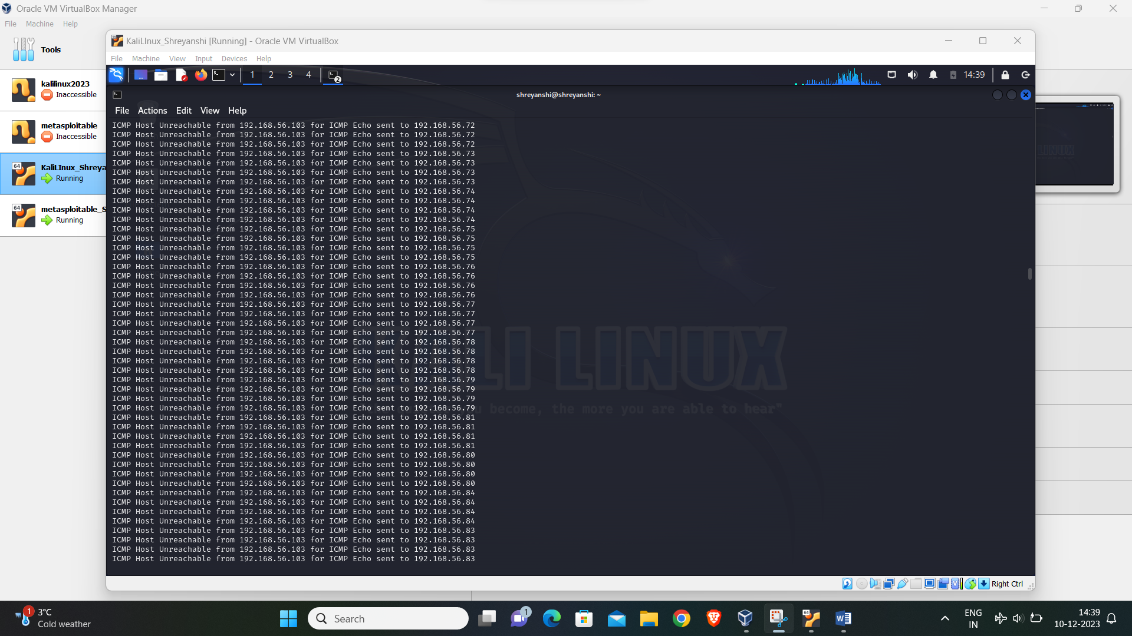

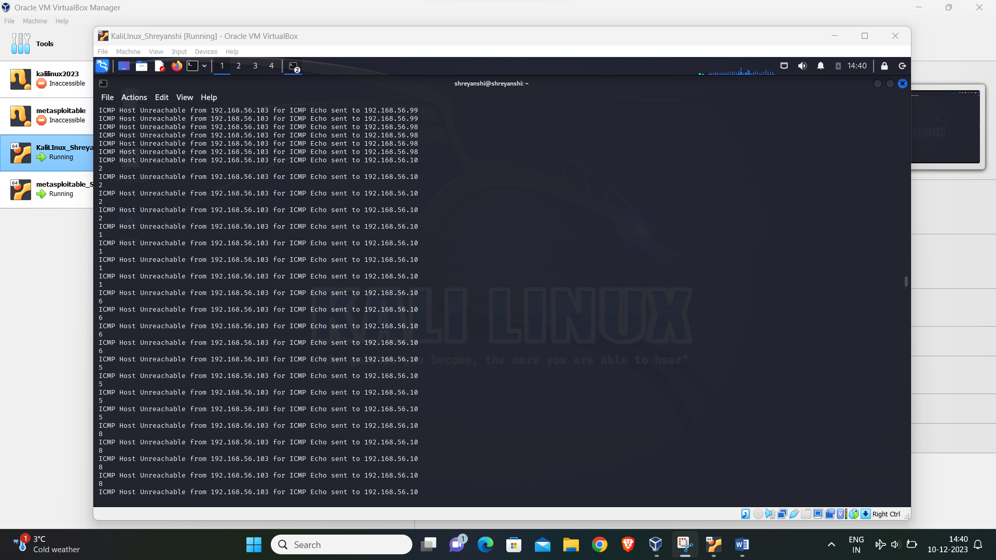

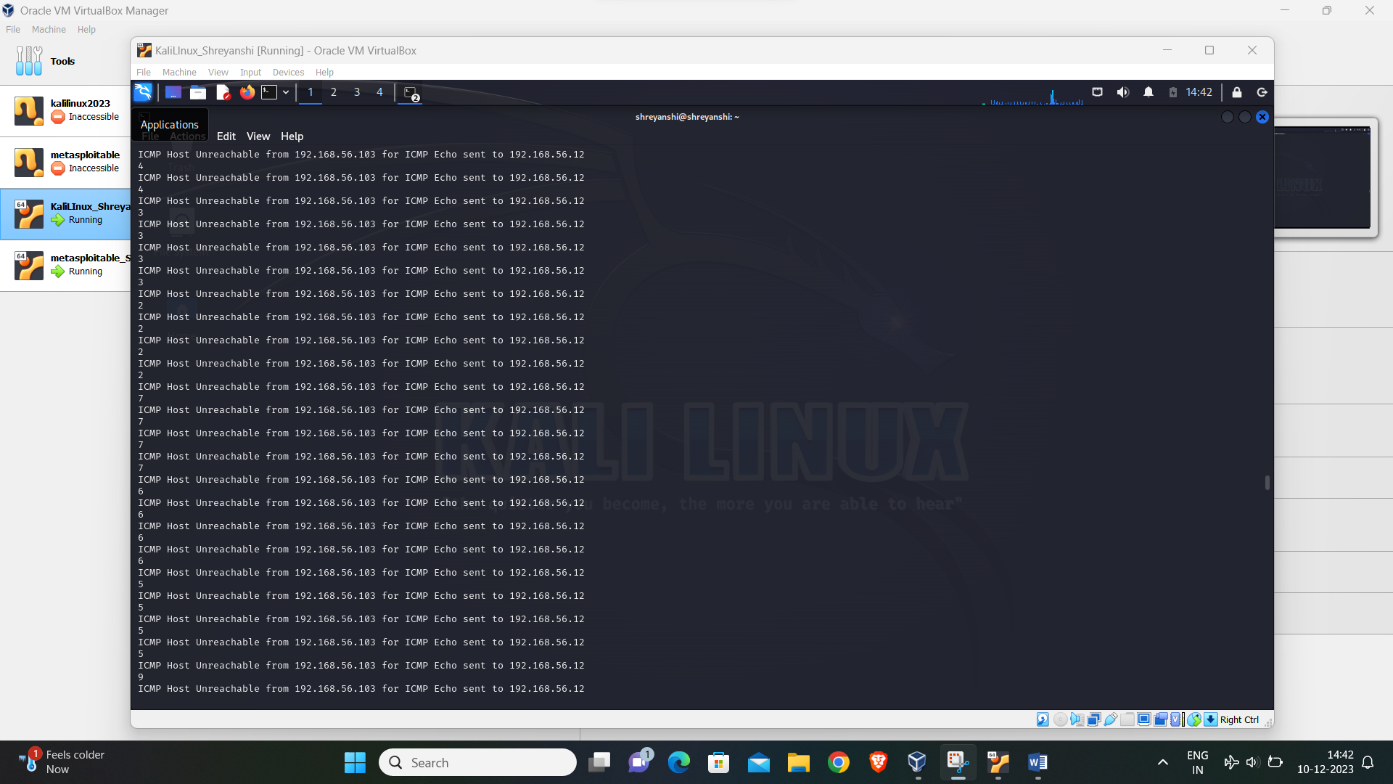

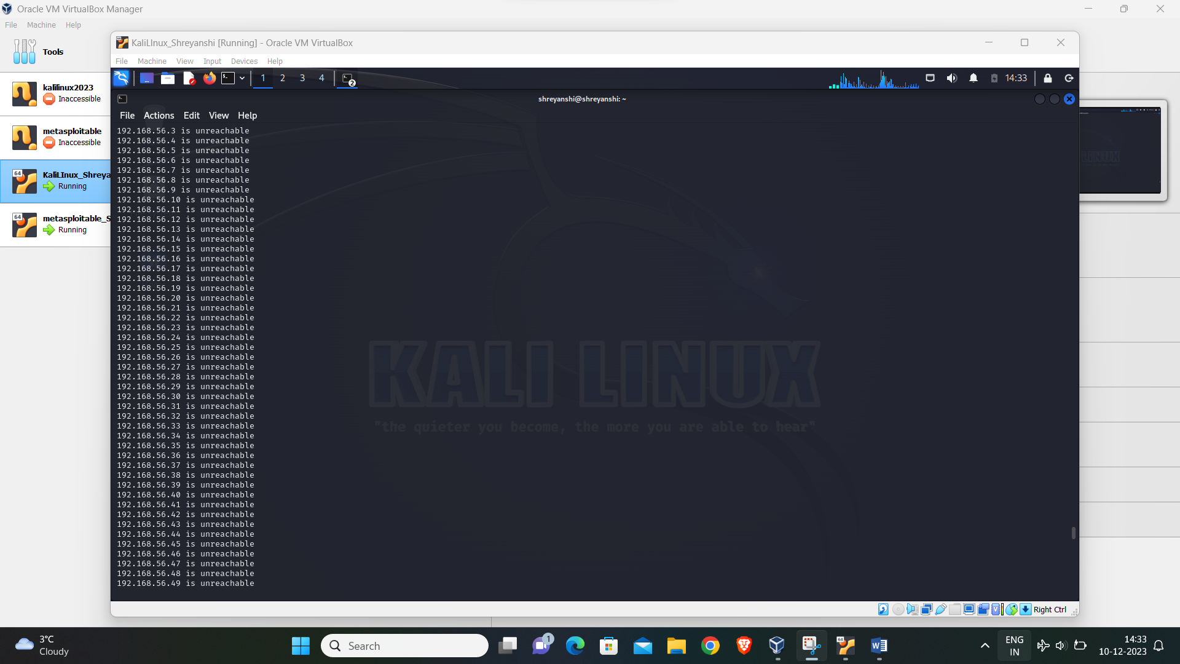

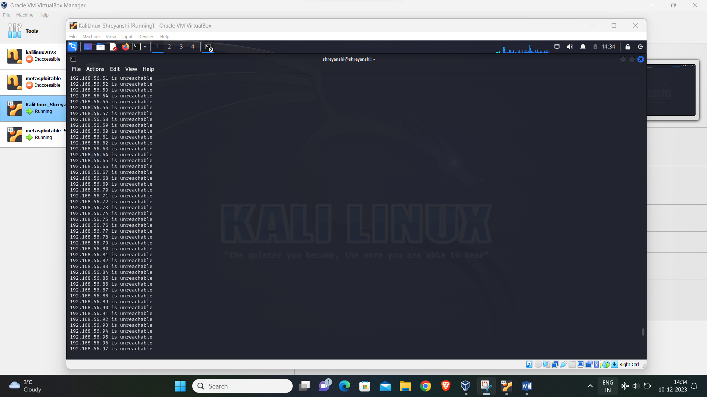

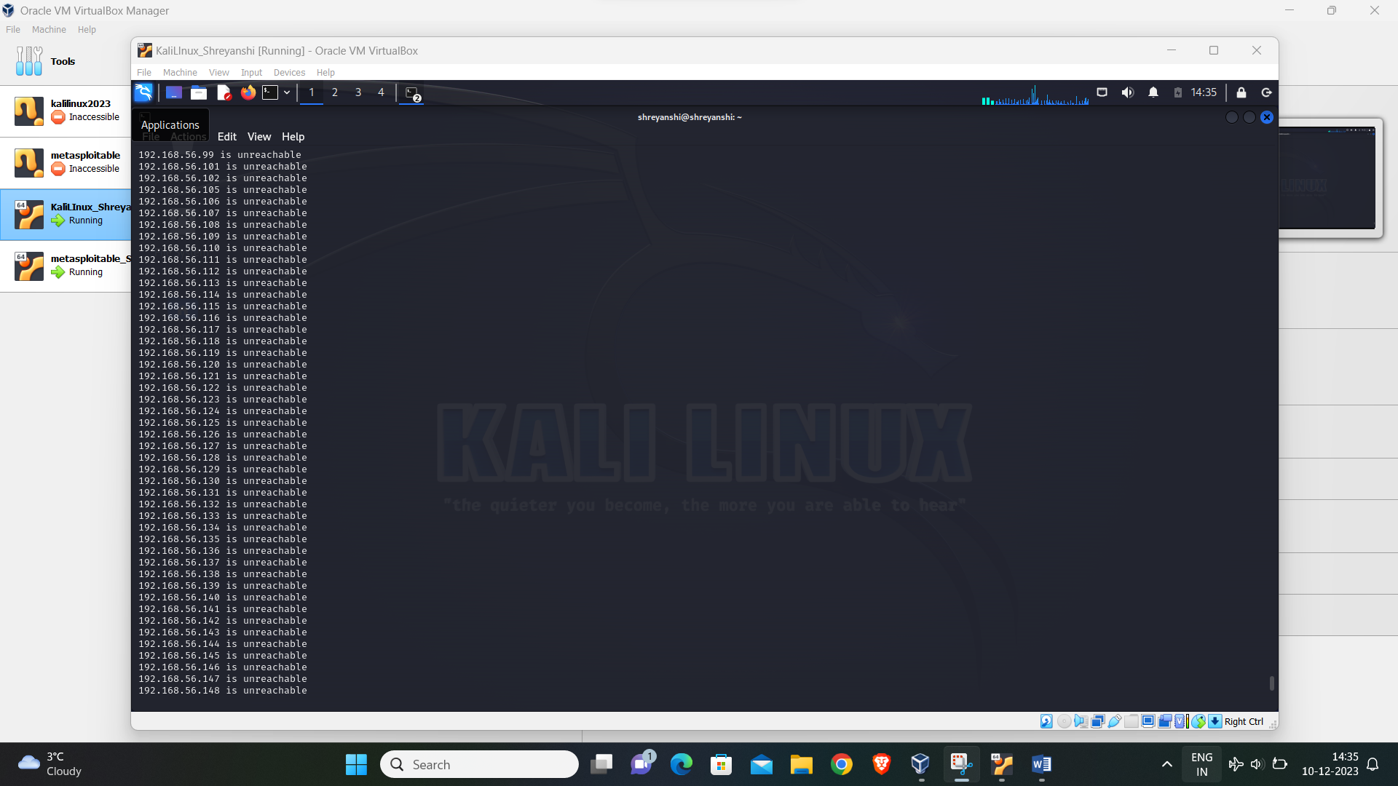

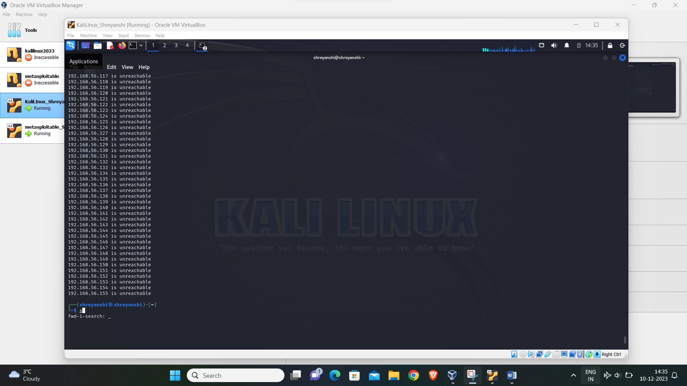

By executing the ifconfig command, I determined that the IP address of my Kali machine is 192.168.56.103. Knowing that Metasploitable2 is on the same network, I inferred its IP address without using the ifconfig or IP command on Metasploitable2. I ran the fping command and found that three IPs are active: 192.168.56.100, 192.168.56.103 and 192.168.56.104. Given that both kali and Metasploitable2 are running on the same machine, I deduced that the IP address of Metasploitable2 should be sequential increment from the Ip address of kali Linux. Therefore, I concluded that 192.168.56.104 is the IP address of Metasploitable2. Furthermore, only two of the IPS were in sequential order, making it evident that 192.168.56.104 is the IP address of Metasploitable2.

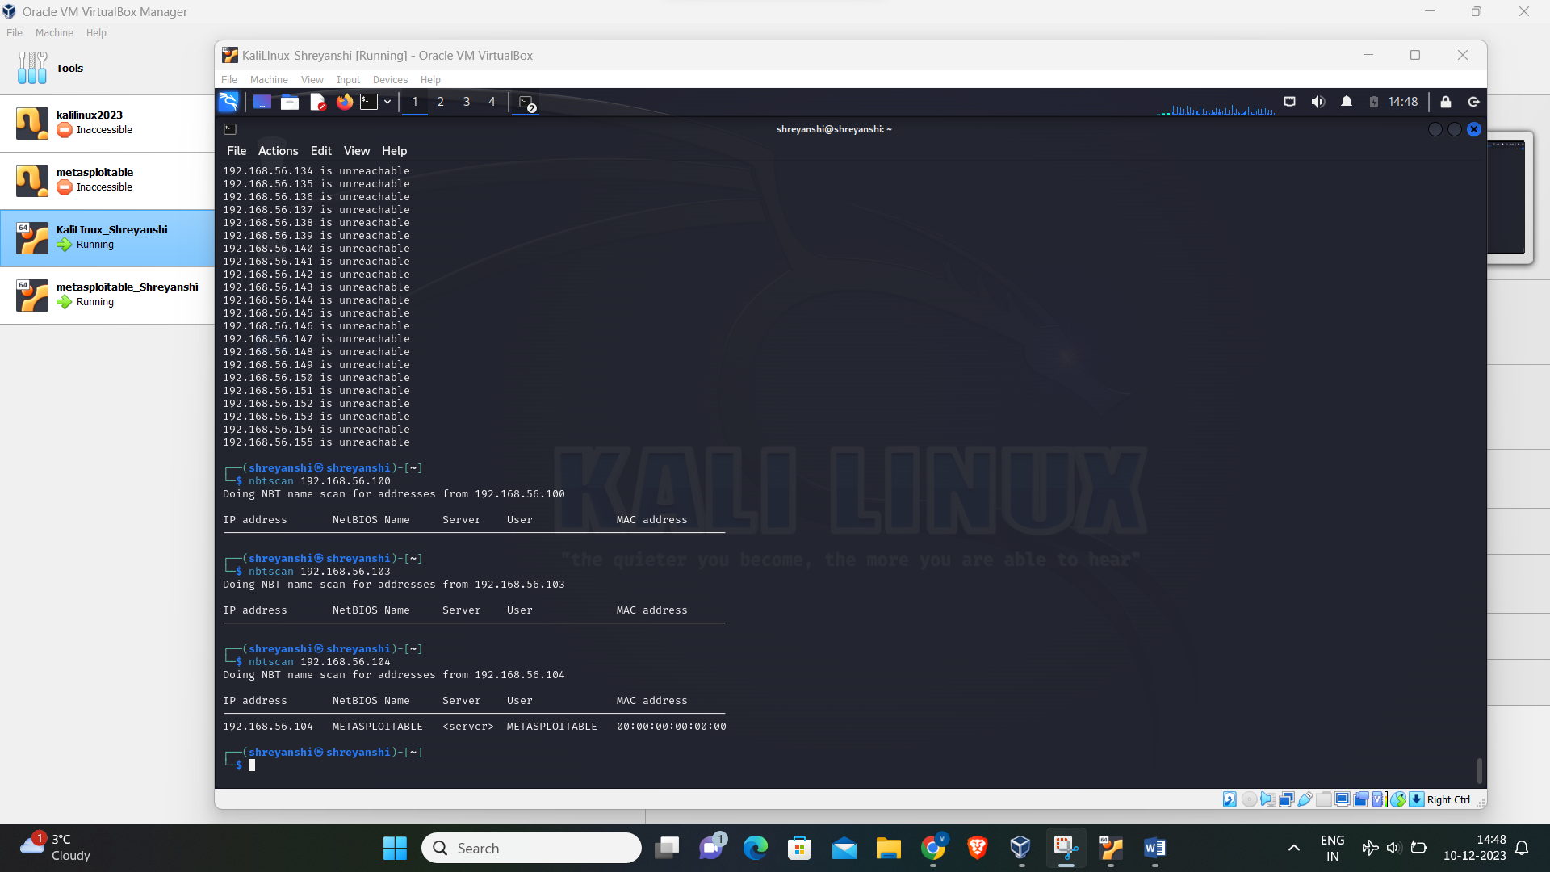

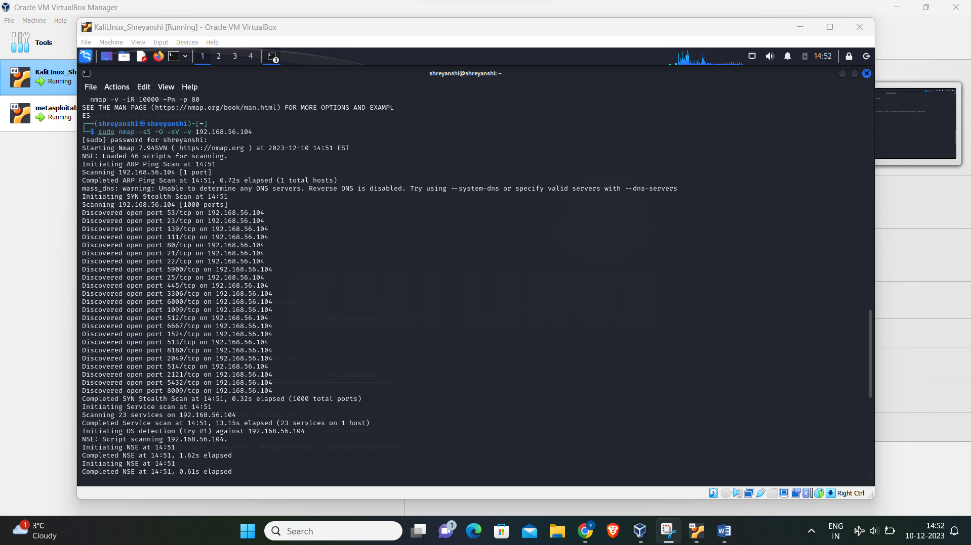

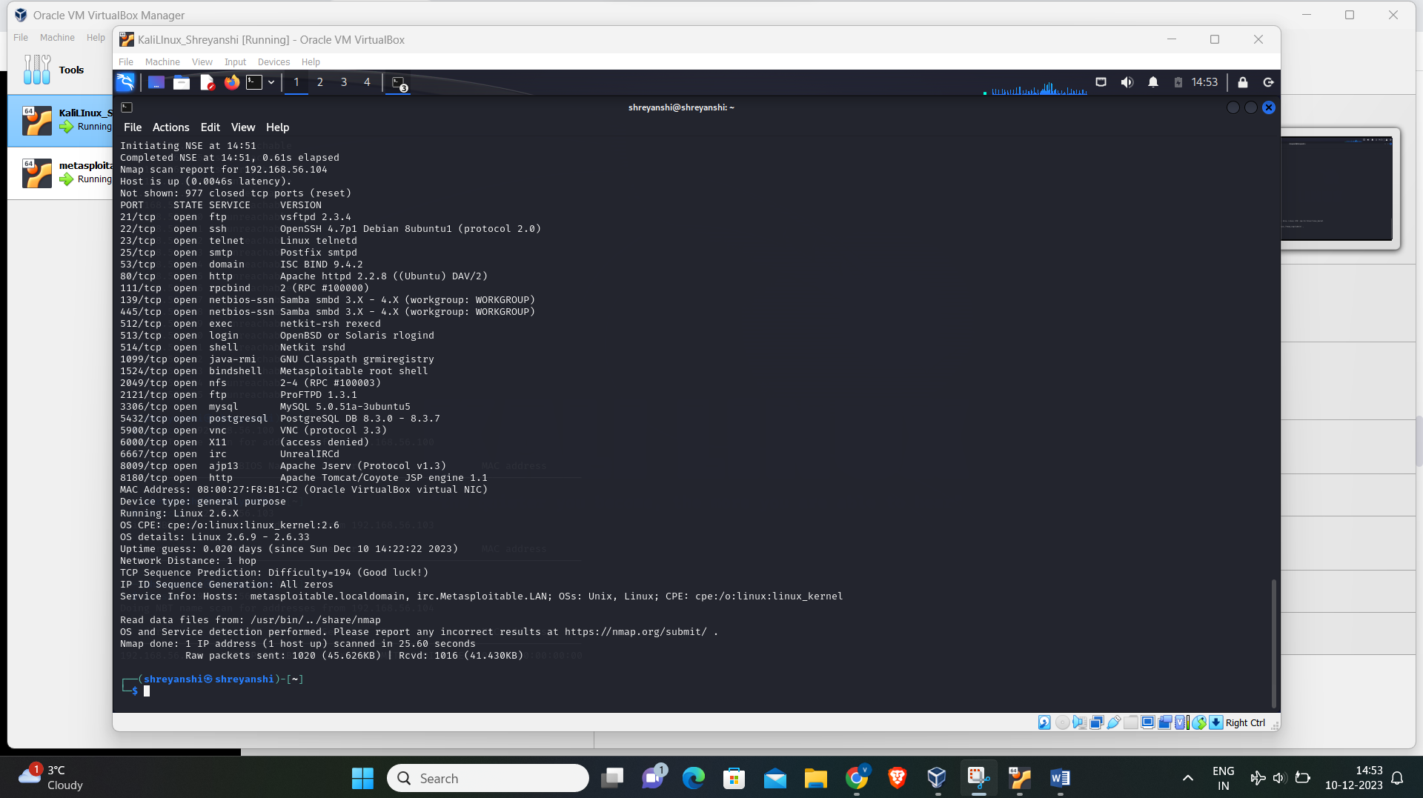

The red box highlights the open port and services while the blue box highlights the service I researched upon.

**Service: Shell Version: NetKit rshd**

* The NetKit, which includes the rshd service was launched on May 4, 2011.
* The latest version of NetKit, which includes the rshd service is 2.8 which was again released on May 4, 2011. However, NetKit is no longer supported and has been replaced by kathara whose released date is not mentioned anywhere on the internet.
* Yes, there is a known vulnerability for the rshd service in NetKit. The vulnerability is identified as CVE-2019-7282.

This vulnerability is present in NetKit versions up to 0.17, due to an issue in the rcp.c file of the rcp client. This issue allows remote rsh servers to bypass intended access restrictions by using a filename of ‘.’ or an empty filename. The result is that it enables the attacker exploiting this flaw to alter the permissions of the target directory on the client side. This vulnerability bears similarity to CVE-2018-206851.

In layman’s terms, this vulnerability could permit an attacker to alter the permissions of directories on the client side by exploiting the way the rcp client processes certain filenames. This could potentially grant the attacker unauthorized access to sensitive data or system resources.

* In the context of a penetration test, the above information is of significant importance. If I could exploit this vulnerability, it could potentially grant me unauthorized access to the system, allowing me to further investigate and identify other potential vulnerabilities. After identifying and documenting this vulnerability, the next step would be to report it to the system owner or administrator. I would likely suggest ways to mitigate the risk, such as updating to a more secure version of the software or implementing additional access controls. Always ensure to conduct penetration testing ethically and with the proper authorization.

**Penetration Test Steps:**

The potential steps for a penetration test based on the standard penetration testing phases for the vulnerability identified in NetKit’s rshd service (CVE-2019-7282):

1. **Reconnaissance**: This is the initial phase where I will gather as much information as possible about the target system. This could verify the NetKit version on the target system. If it’s version 0.17 or below, it’s likely susceptible to CVE-2019-7282.
2. **Scanning**: In this phase, I will utilize tools such as Nmap to perform a scan on the target system, identifying open ports and running services. Check if the rshd service is operational.
3. **Exploitation**: Here, I will attempt to exploit the known vulnerability in the rshd service by developing a specific request to the rshd service that leverages the vulnerability. This could involve sending a filename of ‘.’ or an empty filename to the service.
4. **Maintaining Access**: If the exploit is successful, I might gain the capability to alter the permissions of directories on the client side. This could potentially provide unauthorized access to sensitive data or system resources.
5. **Reporting**: Document my findings, including the vulnerability, potential impact, and suggested mitigation strategies. This could involve updating to a more secure software version or implementing additional access controls.

**Recommendation:** To enhance the system security to protect the system from CVE-2019-7282 vulnerability, clients might need to consider the following measures:

* 1. **Software Updates**: Make sure all software, including the rshd service, is up-to-date. If the software is no longer maintained, as is the case with Netkit, think about switching to a supported alternative.
  2. **Encryption:** Use encryption for sensitive data, both at rest and in transit, to protect it from unauthorized access.
  3. **Network Monitoring**: Implement continuous network monitoring to detect any unusual activity or potential threats.
  4. **Routine Checks**: Carry out regular security checks to spot and fix any potential vulnerabilities
  5. **Access Management**: Enforce strict access control policies, including the use of robust, unique passwords and two-factor authentication.

**References**

1. [Netkit Official Site](https://www.netkit.org/)
2. [rshd(8): remote shell server - Linux man page (die.net)](https://linux.die.net/man/8/rshd)
3. [Kathará | Publications (kathara.org)](https://www.kathara.org/publication.html)
4. [NVD - CVE-2019-7282 (nist.gov)](https://nvd.nist.gov/vuln/detail/CVE-2019-7282)
5. [CVE - Search Results (mitre.org)](https://cve.mitre.org/cgi-bin/cvekey.cgi?keyword=rsh)
6. [7 Penetration Testing Phases and Steps Explained (geekflare.com)](https://geekflare.com/penetration-testing-phases-steps-explained/)
7. [ADV190013 - Security Update Guide - Microsoft - Microsoft Guidance to mitigate Microarchitectural Data Sampling vulnerabilities](https://msrc.microsoft.com/update-guide/en-us/advisory/ADV190013)